

# User Manual

## 13 INCH ELECTRIC PIZZA OVEN

**Pizzetta Primo**

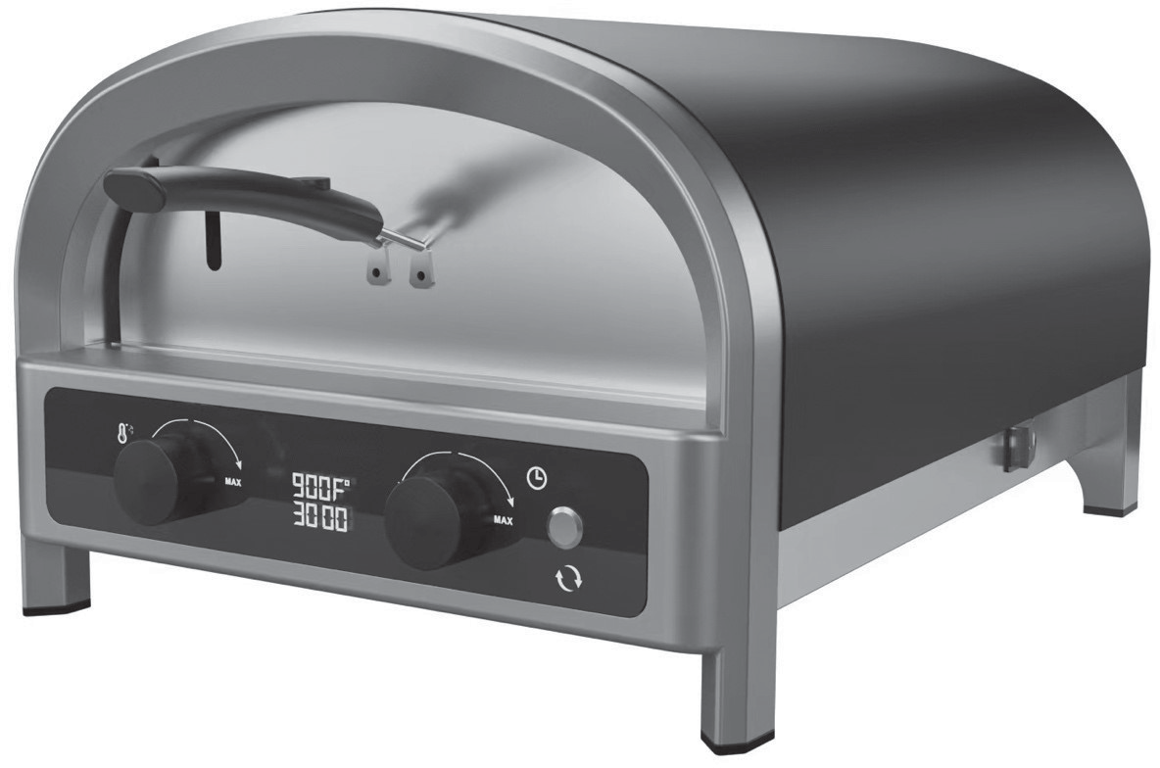

Re1.1 0623

# User Manual

## 13 INCH ELECTRIC PIZZA OVEN

###### DO NOT RETURN THIS PRODUCT TO THE STORE

If you have questions or need assistance, please visit our website:

[https://www.fornigodino.com/](http://www.fornigodino.com/)

### CONTENT

**SAFETY INFORMATION**

IMPORTANT SAFEGUARDS 4

SHORT CORD INSTRUCTIONS 6

**HOW TO USE**

DESCRIPTION OF PARTS 7

HOW TO INSTALL THE DOOR 8

BEFORE FIRST USE 9

OPERATING YOUR OVEN 9

SETTING OF TEMPERATURE 10

SETTING OF TIME 10

IMPORTANT NOTICE 11

**CLEANING AND CARE**

STORING 12

**TROUBLESHOOTING** 13

**DISPOSAL** 14

**INFORMATION AND SERVICE** 14



### SAFETY INFORMATION

| **DANGER** |
| --- |
| **DANGER** – Immediate hazards which **WILL** result in severe personal injury or death |

| **WARNING** |
| --- |
| **WARNING** – Hazards or unsafe practices which **COULD** result in severe personal injury or death |

| **CAUTION** |
| --- |
| **CAUTION** – Hazards or unsafe practices which **COULD** result in minor personal injury |

| **WARNING** |
| --- |
| When using electrical appliances, basic safety precautions should always be followed, including the following |

###### INSTALLER/ASSEMBLER:

Leave this manual with consumer.

###### CONSUMER:

Keep this manual for future reference.

**This instruction manual contains important information necessary for the safe use of the appliance.**

**Follow all warnings and instructions when using the appliance.**

#### IMPORTANT SAFEGUARDS

READ ALL INSTRUCTIONS BEFORE USE AND SAVE FOR FUTURE REFERENCE

When using electrical appliances, basic safety precautions should always be followed including:

1. Remove and safely discard any packing materials and promotional labels before using the oven for the first time.
2. To avoid choking hazard for young children, remove and safely dispose of the protective cover fitted on the power plug.
3. Do not use the appliance near the edge of a countertop or table. Ensure the surface is stable, level, heat- resistant and clean.
4. Do not use on a cloth-covered surface, near curtains or other flammable materials.
5. A fire may occur if the oven is covered or touches flammable materials, including curtains, draperies, walls, and the like, when in operation.
6. Do not use the appliance on(or close to) a hot gas or electric burner, or where it could touch a heated oven or surface.
7. Do not let the power cord hang over the edge of a table or counter, touch hot surfaces or become knotted.
8. To avoid electric shock, do not immerse the cord, plug or motor base in water

### SAFETY INFORMATION

1. The outer housing of the oven may be hot during and after cooking. Please do not touch hot surfaces. Always keep the power cord of this oven, and those of other appliances near the oven, clear from the oven housing.
2. The oven is not suitable to be used in a small appliance enclosure. Ensure to leave adequate space all around the oven. Minimum space of 4 inches/10cm is recommended.
3. Do not touch hot surfaces.
4. To avoid burns, use extreme caution when removing the included pizza pan or pizza stone as they might be very hot.
5. Do not place cardboard, plastic, paper, or other flammable materials in the oven.
6. Do not cover any part of the oven with metal foil. This will cause overheating of the oven.
7. We recommend using the dedicated pizza stone with the oven, although other cast iron/ carbon steel pans that fit are also suitable for usage.
8. Do not use non-stick or coated pans in the oven.
9. Oversized food and metal utensils must not be inserted in the oven as they may create fire or risk of electric shock.
10. To avoid any direct contact with the oven, a pizza peel should be used at all times when inserting a pizza into the cavity, unless cooking a pan pizza.
11. The use of accessories and attachments not recommended or supplied with this oven may cause injuries.
12. Do not store any materials, other than manufacturers recommended accessories, in this oven when not in use.
13. This appliance is for household use only. Do not use in any type of moving vehicles.
14. If the appliance is to be cleaned, moved, assembled or stored, always switch the unit off and allow it to cool completely, before unplugging it from the power outlet.
15. Do not clean with metal scouring pads. Pieces can break off the pad and touch electrical parts, creating a risk of electric shock.
16. Close supervision is necessary when the appliance is used by or near children.
17. Longer detachable power- supply cords or extension cords are available and may be used if care is exercised in their use.
18. It is recommended to regularly inspect the appliance and power cord.
19. Do not use the appliance if there is damage to the power cord or plug, or after the appliance malfunctions or has been damaged in any way. Immediately stop use and call Fornigodino Consumer Support.

### SAFETY INFORMATION

1. We recommend operating the oven on a dedicated circuit separated from other appliances. Consult a licensed and qualified electrician if you are unsure.
2. This appliance is equipped with a power cord having a grounding wire with a grounding plug. The appliance must be grounded using a 3-hole properly

grounded outlet. In the event of an electrical short circuit, grounding reduces the risk of electrical shock.

1. Do not, under any circumstances, cut or remove the third (ground) prong from the power cord or use an adapter.
2. Consult a qualified electrician if the grounding instructions are not completely understood, or if doubt exists as to whether the appliance is properly grounded.
3. The installation of a residual current device (safety switch) is recommended to provide additional safety protection when using electrical appliances. It is advisable that a safety switch with a rated residual operating current not

exceeding 30mA be installed in the electrical circuit supplying the appliance. See your electrician for professional advice.

##### WARNING

To prevent electric shock, unplug before cleaning.

#### SHORT CORD INSTRUCTIONS

1. This appliance is fitted with a short power supply cord to reduce personal

injury or property damage resulting from pulling, tripping or becoming entangled with a longer cord.

1. If an extension cord is used,
   1. the marked electrical rating of the cord set or extension cord should be at least as great as the electrical rating of the appliance,
   2. the cord should be arranged so that it will not drape over the countertop or table-top where it can be pulled on by children or tripped over unintentionally and
   3. the extension cord must include a 3-prong grounding plug.

**FOR HOUSEHOLD USE ONLY SAVE THESE INSTRUCTIONS**

### HOW TO USE

#### DESCRIPTION OF PARTS

##### COMPONENTS

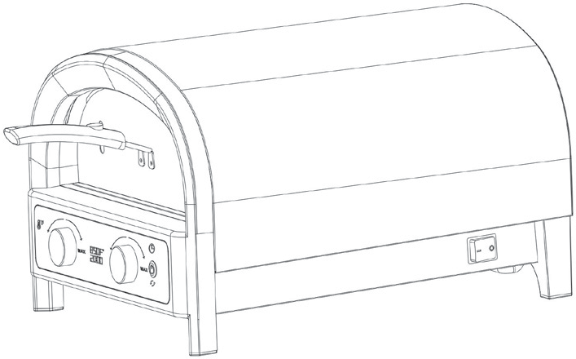

Device Overview and Operating Elements



### HOW TO USE

1. Power cord
2. Temperature Dial
3. LCD display
4. Timer Dial
5. Rotation Button
6. Detachable door (assemble with part 7)
7. Door handle (assemble with part 6)
8. Pizza stone
9. Power switch

#### HOW TO INSTALL THE DOOR

Step 1: Install the handle to the door plate.

(The screws and nuts have been pre-installed on the handles Unscrew & reinstall the handle to the door plate )

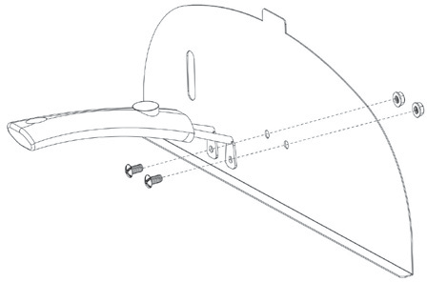

Step 2: Attach the door to oven.

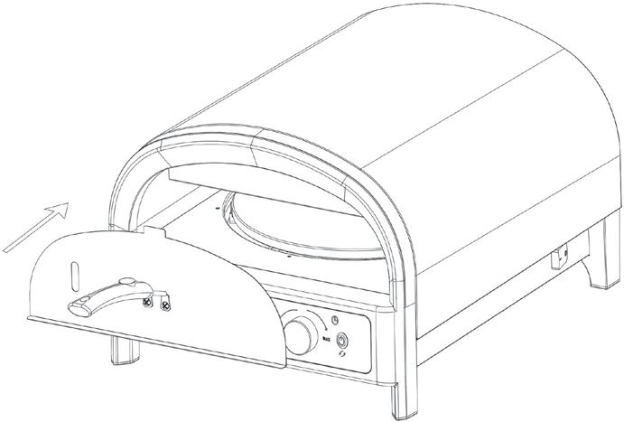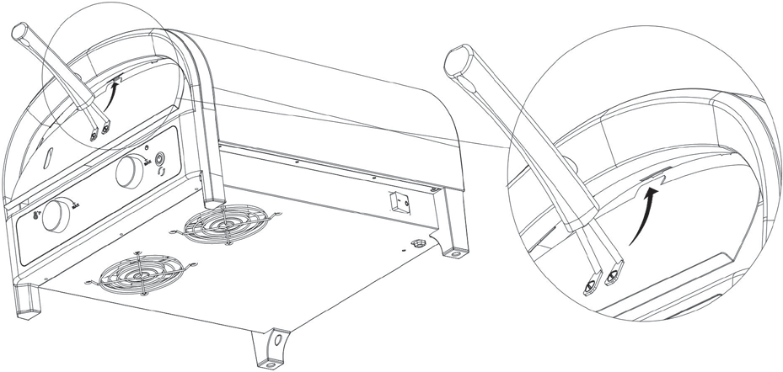

### HOW TO USE

#### BEFORE FIRST USE

##### Functions

In order to remove any protective substances on the heating elements, it is necessary to run the oven empty for 20 minutes. Ensure the area is well ventilated as the oven may emit vapors. These vapors are safe and are not detrimental to the performance of the oven.

1. Remove and safely discard any packing material, promotional labels and tape from the oven.
2. Remove the pizza stone from its packaging and place the pizza stone in the oven cavity.
3. Wipe the interior of the oven with a soft, damp sponge.
4. Place the oven on a a clean, flat, stable surface. Clear the space before moving your oven into position. Remove any flammable objects and materials, including table cloths. Think about ventilation when choosing a suitable place for your oven. Very high cooking temperatures can sometimes cause food

to burn, which can produce smoke. Ensure there is a minimum distance of 4" (10cm) of space on both sides of the oven and 6” (15cm) above.

1. Unwind the power cord completely and insert the power plug into a grounded power outlet.
2. Switch on the POWER ON, the oven will sound and the display will illuminate for 3 seconds and then turn off.
3. Press the TEMP DIAL, the display will show the recommended TEMP and TIME, press the TEMP dial one more time to start the oven.
4. Put the door on and let the oven run for 20 minutes.
5. The oven is now ready to use.

#### OPERATING YOUR OVEN

Due to the extremely high temperatures being achieved, please ensure to place the

oven in a well-ventilated area, as it will emit smoke when cooking.

1. Insert the pizza stone into the pizza oven cavity.
2. Insert the power plug into a grounded power outlet.
3. The oven alert will sound and the dispaly will illuminate for 3 seconds and then turn off. The oven enters standby model.
4. Press the TEMP dial, the TEMP and TIME indicator light will flash and display the recommended TEMP and TIME specific to the setting.

### HOW TO USE

*C9*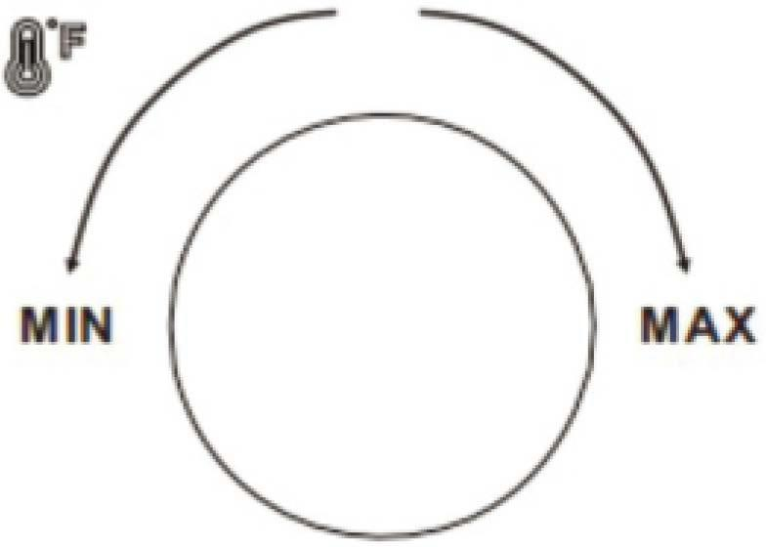

1. Press the TEMP dial to start the oven.
2. Allow the oven to preheat until the set temperature reached, the preheating time can vary between 0–60 minutes depending on the selected preset. Use the detachable door can shorten the preheating time.
3. Use a pizza peel to place the pizza directly on the pizza stone.
4. Press the TIME dial to start the countdown timer.
5. At the end of the cooking cycle, the oven alert will sound and the TIME dial lights will flash and then go out.
6. Remove your pizza and enjoy.

#### SETTING OF TEMPERATURE

1. Turn left-hand TEMP dial clockwise to raise the oven temperature, press the

dial to SET the desired temperature.

1. Turn TEMP dial counter clockwise to lower the oven temperature, press the dial to SET the desired temperature.
2. Temperature set to 500C (Max Temp).
3. Press and the Temp dial and hold for 2 seconds to stop the heating, the device will enter standby mode.
4. The oven temperature can be adjusted during the course by pressing the TEMP dial, when the TEMP indicator flash, turn the dial to get your desired value and press once to set.

#### SETTING OF TIME

1. Turn TIME dial counter clockwise to reduce the amount of the time on the

timer, or rotate to 0 to cancel, press the dial to SET desired time.

1. Turn TIME dial clockwise to increase the amount of the time on the timer, maximal cooking time is 60 minutes.
2. Once the timer is complete, the oven stops heating and the device enter standby mode.
3. Press the TEMP dial to start another cycle if needed.

### HOW TO USE

###### NOTE

When you intend to transport the product; remove the pizza stone from inside the oven and pack separately to avoid breakage.

###### NOTE

Make sure the oven is preheated before placing the pizza in the cavity.

###### NOTE

For high temperature cooking functions,

we recommend you monitor and stay close to the oven as your food can quickly become overdone and eventually ignite.

See Troubleshooting for more information.

###### WARNING

After cooking, allow the oven to cool completely before unplugging from the wall. Fans will continue to run to cool.

The sensitive electronics. These fans will automatically turn off when the temperatures are at an acceptable level.

#### IMPORTANT NOTICE

Your pizza oven requires a full 16-amp electric power outlet to operate properly.

Running it on a lower current outlet/circuit breaker may cause the grill and/or circuit to trip. To prevent power loss:

* An exterior outlet with a standard 16-amp circuit breaker is recommended.
* Unplug any other electrical devices, like patio lights, powered by the exterior outlet/circuit breaker before plugging in your grill.

If power is lost during use:

* Identify and unplug any other electrical devices that lost power at the same time and reset the breaker.
* Try using a different electrical outlet, if available. Check your owner’s manual for recommended use of extension cords. If your circuit breaker continues to trip during use, consult a qualified electrician.

### CLEANING AND CARE

* The appliance should not require any interior cleaning. Any food residue should burn off when in use. You can use the brush to sweep away excess debris on the stone.
* Over time the interior of the device may discolor slightly. This is completely normal.
* Don’t use oven cleaners or metal scourers to clean your pizza oven because they will damage the machine, Wipe the outer body with a soft, damp sponge. A non-abrasive liquid cleanser or mild spray solution may be used to avoid build-up of stains. Apply the cleanser to the sponge, not the oven surface, before cleaning.
* To clean the outside of your pizza oven, wait until it’s cool, unplug it and use a lightly damp cloth to wipe the oven body. Dry with a clean towel right away.
* Let all surfaces dry thoroughly prior to inserting the power plug into a power outlet and turning the oven on.

#### STORING

You can use the pizza oven outside. Store indoors in dry conditions when not in

use.

Only store the pizza stone inside the oven — don’t store food or other items in the oven cavity.

Do not lean on or put items on top of your device. Doing so could damage your oven.

##### Pizza Stone

1. DO NOT use the pizza stone over an open flame.
2. Avoid extreme temperature change to the stone. DO NOT place frozen foods onto the stone if using temperatures in excess of 200°C.
3. The stone is fragile and can break if bumped or dropped.
4. The stone is very hot during use and stays hot for a long time after use.
5. DO NOT cool the stone with water or use it when damp.
6. To clean off burned food marks, wait until the stone is cool, use two hands to carefully take it out of the oven, remove any loose or large debris, then flip it over and slide it gently back in. The debris on the underside of the stone will burn away the next time you use your appliance.
7. If your stone breaks: Turn your oven off, let it cool and unplug it before you remove the broken baking stone.



| **Problem** | **Possible reason** | **Solution** |
| --- | --- | --- |
| The appliance produces smoke when it is on. | Food is touching the heating element. | Switch off the product and re- position the food until it is not touching the heating element. |
| The food is smoking without touching the heating element. | Interrupt the grilling process immediately and allow the device to cool. Do not reheat the food. |
| The product is used for the first time. | There is a protective oil on the surface of the product . |
| The appliance is not responding or does not heat up. | Plug is not plugged in. | Insert the plug into the mains socket. |
| The appliance is not switched on. | Push the power button at the back of the appliance. |
| Timer has finished counting. | Turn on the appliance again. |
| The fuse has fused. | Contact the authorized service agent. |
| The appliance has overheated. | If the appliance overheats, it will automatically turn off the heating system for safety. Stop using  the appliance and contact the  authorized service agent. |
| Month board is broken. | Contact Fornigodino to get replacement. |
| The outside surface of the appliance is very hot. | Blocked air vents. | Remove any items that may be blocking the vents. |
| Blocked air intakes. | Make sure that the surrounding of air intakes underneath the unit are cleared. |
| Pizza stone does not rotate. | The rotation button is off. | Press the button to start the rotation. |
| Rotation motor is broken. | Contact Fornigodino to repair. |

### DISPOSAL

Proper disposal of this product.

This symbol indicates that this appliance may not be treated as household waste. Instead, it should be taken to the appropriate collection point for

 recycling electrical and electronic equipment.

Please use the return or collections services available in your community or contact the retailer where you purchased this product.

### INFORMATION AND SERVICE

If you have questions or concerns about your product, please visit our website:

[https://www.fornigodino.com/](http://www.fornigodino.com/)

In line with our policy of continuous product development, we reserve the right to change the product, packaging and documentation specifications without prior notice.

Model: Panetti Pizzetta Primo

Voltage: 240 V~ 60 Hz

Power: 2400 W